Laurie Mailloux

Assignment 1.5

February 18, 2020

The first portfolio page I found was very simple, but also eye catching with it’s simplicity. There is nothing fancy about it, just a simple page with a little informaiton about the person. It offered access to his Linkedln and Twitter account along with the option to contact him with a personal message. I think it provides the minimal amount of information, but enough to peek your interest.

<http://redrussak.com/>

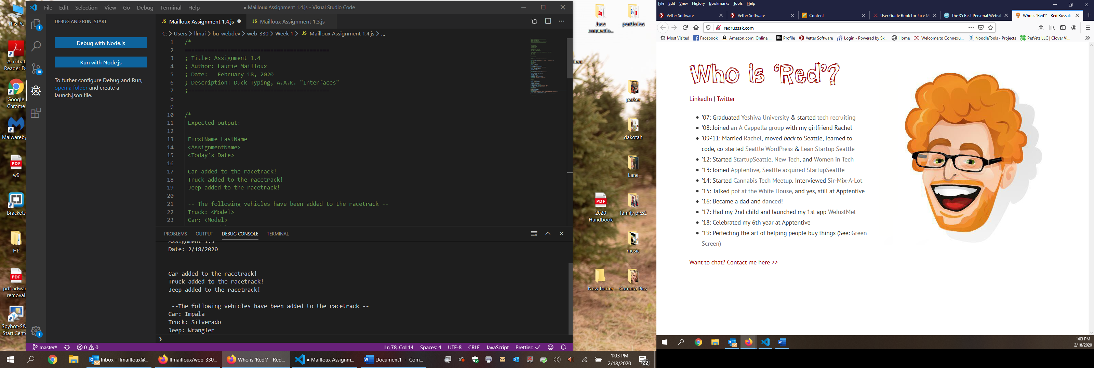

The second one that caught my eye was the following one. It again is very simple offering just enough info without over doing it. It offers a fun pattern with fun colors and access to numerous features. It gives you access to his Twitter, Instagram and Github. It also offers you the option to email him with your needs. It gives a description of what he does and also provides the current company he works for. I think it is a great functioning website with a significant amount of information.

<http://mrcthms.com/>

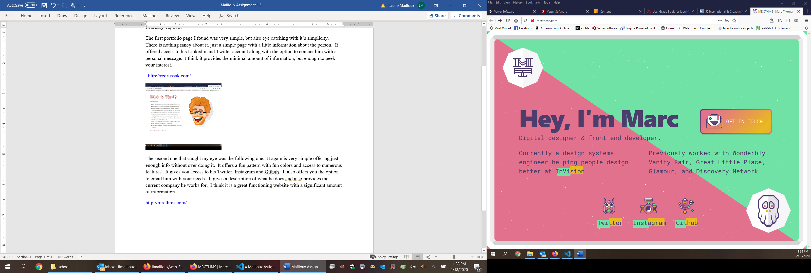

The last one I looked at was a lot more complex, extremely detailed, but it was so much fun. It’s in interactive resume that takes you through everything like a game. It portrays a video game while running through his resume as a character. It is colorful and animated, like a cartoon. It gives a lot of detailed information about his experience with different programs and about him and his history and work experience. The functionality of this one is a bit more complex than most, but the interaction makes up for it. It offers numerous ways to get in contact with him. The layout and style he uses makes for a fun experience.

<http://www.rleonardi.com/>

